Experiment 1:
Implement three nodes point – to – point network with duplex links between them. Set the queue size, vary the bandwidth and find the number of packets dropped.
Step1: Open text editor, type the below program and save with extention .tcl (prog1.tcl ) set ns [new Simulator]
set nf [open prog1.nam w]
$ns namtrace-all $nf
set nd [open prog1.tr w]
$ns trace-all $nd

proc finish { } { global ns nf nd
$ns flush-trace close $nf close $nd
exec nam prog1.nam & exit 0
}

set n0 [$ns node] set n1 [$ns node] set n2 [$ns node]

$ns duplex-link $n0 $n1 1Mb 10ms DropTail
$ns duplex-link $n1 $n2 512kb 10ms DropTail
$ns queue-limit $n1 $n2 10

set udp0 [new Agent/UDP]
$ns attach-agent $n0 $udp0
set cbr0 [new Application/Traffic/CBR]
$cbr0 set packetSize_ 500
$cbr0 set interval_ 0.005
$cbr0 attach-agent $udp0 set sink [new Agent/Null]
$ns attach-agent $n2 $sink
$ns connect $udp0 $sink

$ns at 0.2 "$cbr0 start"
$ns at 4.5 "$cbr0 stop"
$ns at 5.0 "finish"
$ns run
Step2: Open text editor, type the below program and save with extention .awk (prog1.awk ) BEGIN {
dcount = 0;
rcount = 0;
}
{
event = $1; if(event == "d")
{
dcount++;
}
if(event == "r")
{
rcount++;
}
} END {
printf("The no.of packets dropped : %d\n ",dcount); printf("The no.of packets recieved : %d\n ",rcount);
}

Step3: Run the simulation program

[root@localhost~]# ns prog1.tcl
(Here “ns” indicates network simulator. We get the topology shown in the snapshot.)

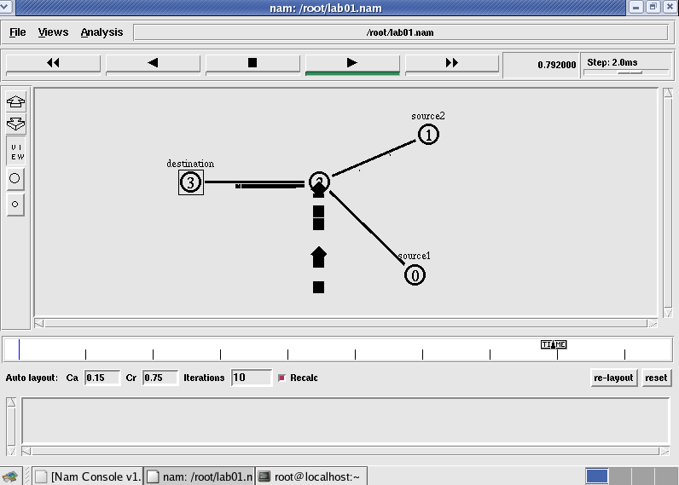

Step 4: Now press the play button in the simulation window and the simulation will begins.

Step 5: After simulation is completed run awk file to see the output ,

[root@localhost~]# awk –f prog1.awk prog1.tr
Number of packets droped = 16

Step 6: To see the trace file contents open the file as ,

[root@localhost~]# vi prog1.tr
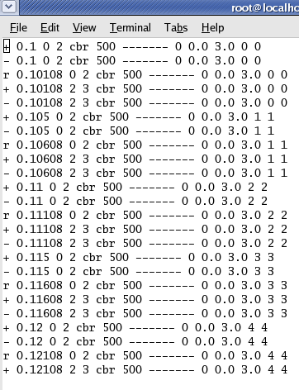

Experiment 2:
Implement transmission of ping messages/trace route over a network topology consisting of 6 nodes and find the number of packets dropped due to congestion.
Step1: Open text editor, type the below program and save with extention.tcl (prog3.tcl ) set ns [new Simulator]
set nf [open prog3.nam w]
$ns namtrace-all $nf
set nd [open prog3.tr w]
$ns trace-all $nd

proc finish {} { global ns nf nd
$ns flush-trace close $nf close $nd
exec nam prog4.nam & exit 0
}
set n0 [$ns node] set n1 [$ns node] set n2 [$ns node] set n3 [$ns node] set n4 [$ns node] set n5 [$ns node] set n6 [$ns node]

$ns duplex-link $n1 $n0 1Mb 10ms DropTail
$ns duplex-link $n2 $n0 1Mb 10ms DropTail
$ns duplex-link $n3 $n0 1Mb 10ms DropTail
$ns duplex-link $n4 $n0 1Mb 10ms DropTail
$ns duplex-link $n5 $n0 1Mb 10ms DropTail
$ns duplex-link $n6 $n0 1Mb 10ms DropTail

Agent/Ping instproc recv {from rtt} {
$self instvar node_
puts "node [$node_ id] recieved ping answer from \
$from with round-trip-time $rtt ms."
}
set p1 [new Agent/Ping] set p2 [new Agent/Ping] set p3 [new Agent/Ping] set p4 [new Agent/Ping] set p5 [new Agent/Ping] set p6 [new Agent/Ping]

$ns attach-agent $n1 $p1
$ns attach-agent $n2 $p2
$ns attach-agent $n3 $p3
$ns attach-agent $n4 $p4
$ns attach-agent $n5 $p5
$ns attach-agent $n6 $p6

$ns queue-limit $n0 $n4 3
$ns queue-limit $n0 $n5 2
$ns queue-limit $n0 $n6 2

$ns connect $p1 $p4
$ns connect $p2 $p5
$ns connect $p3 $p6

$ns at 0.2 "$p1 send"
$ns at 0.4 "$p2 send"
$ns at 0.6 "$p3 send"
$ns at 1.0 "$p4 send"
$ns at 1.2 "$p5 send"
$ns at 1.4 "$p6 send"
$ns at 2.0 "finish"
$ns run

Step2: Open text editor, type the below program and save with extention .awk (prog3.awk ) BEGIN {
count=0;
}
{
event=$1; if(event=="d")
{
count++;
}
} END {
printf("No of packets dropped : %d\n",count);
}
Step3: Run the simulation program

[root@localhost~]# ns prog3.tcl
(Here “ns” indicates network simulator. We get the topology shown in the snapshot.)

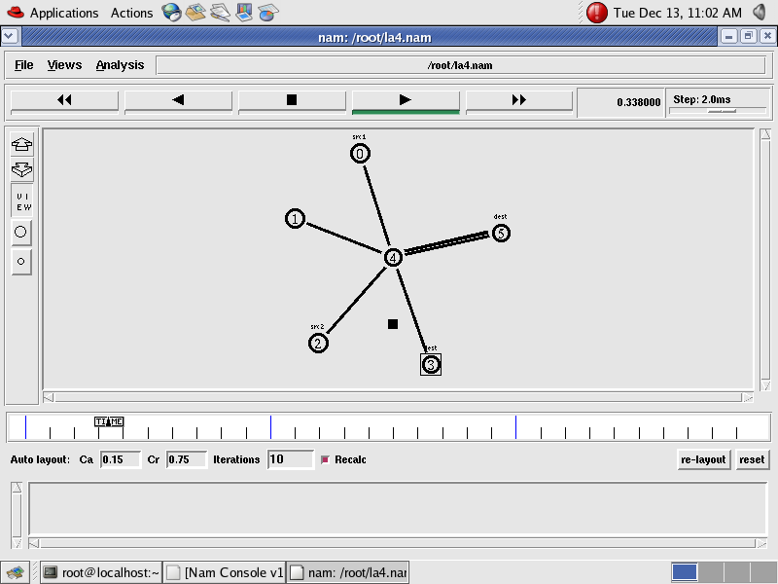
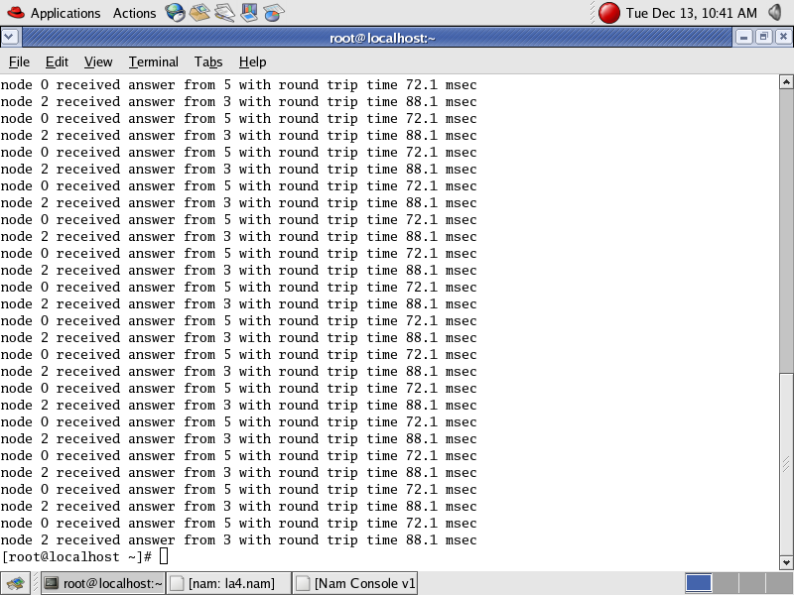

Step 4: Now press the play button in the simulation window and the simulation will begins.

Step 5: After simulation is completed run awk file to see the output ,

[root@localhost~]# awk –f prog3.awk prog3.tr
Step 6: To see the trace file contents open the file as ,

[root@localhost~]# vi prog3.tr

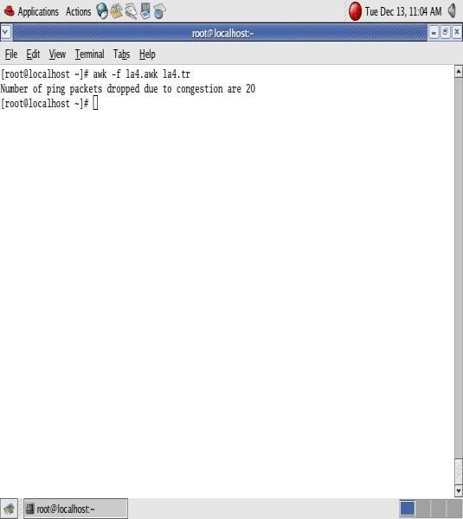

Experiment 3:
Implement an Ethernet LAN using n nodes and set multiple traffic nodes and plot congestion window for different source / destination.
Step1: Open text editor, type the below program and save with extention .tcl (prog5.tcl )

set ns [new Simulator]
set nf [open prog5.nam w]
$ns namtrace-all $nf
set nd [open prog5.tr w]
$ns trace-all $nd

$ns color 1 Blue
$ns color 2 Red
proc finish { } { global ns nf nd
$ns flush-trace close $nf close $nd
exec nam prog5.nam & exit 0
}

set n0 [$ns node] set n1 [$ns node] set n2 [$ns node] set n3 [$ns node] set n4 [$ns node] set n5 [$ns node] set n6 [$ns node] set n7 [$ns node] set n8 [$ns node]

$n7 shape box
$n7 color Blue
$n8 shape hexagon
$n8 color Red
$ns duplex-link $n1 $n0 2Mb 10ms DropTail
$ns duplex-link $n2 $n0 2Mb 10ms DropTail
$ns duplex-link $n0 $n3 1Mb 20ms DropTail

$ns make-lan "$n3 $n4 $n5 $n6 $n7 $n8" 512Kb 40ms LL Queue/DropTail Mac/802_3

$ns duplex-link-op $n1 $n0 orient right-down
$ns duplex-link-op $n2 $n0 orient right-up
$ns duplex-link-op $n0 $n3 orient right

$ns queue-limit $n0 $n3 20

set tcp1 [new Agent/TCP/Vegas]
$ns attach-agent $n1 $tcp1
set sink1 [new Agent/TCPSink]
$ns attach-agent $n7 $sink1
$ns connect $tcp1 $sink1
$tcp1 set class_ 1
$tcp1 set packetsize_ 55

set ftp1 [new Application/FTP]
$ftp1 attach-agent $tcp1

set tfile [open cwnd.tr w]
$tcp1 attach $tfile
$tcp1 trace cwnd_

set tcp2 [new Agent/TCP/Reno]
$ns attach-agent $n2 $tcp2
set sink2 [new Agent/TCPSink]
$ns attach-agent $n8 $sink2
$ns connect $tcp2 $sink2
$tcp2 set class_ 2
$tcp2 set packetSize_ 55

set ftp2 [new Application/FTP]
$ftp2 attach-agent $tcp2

set tfile2 [open cwnd2.tr w]
$tcp2 attach $tfile2
$tcp2 trace cwnd_
$ns at 0.5 "$ftp1 start"

$ns at 1.0 "$ftp2 start"
$ns at 5.0 "$ftp2 stop"
$ns at 5.0 "$ftp1 stop"

$ns at 5.5 "finish"
$ns run
Step2: Open text editor, type the below program and save with extention .awk (prog5.awk ) BEGIN {
}
{
if($6=="cwnd_") { printf("%f\t%f\n",$1,$7);
}
}

END {
}

Step3: Run the simulation program

[root@localhost~]# ns prog5.tcl
(Here “ns” indicates network simulator. We get the topology shown in the snapshot.)
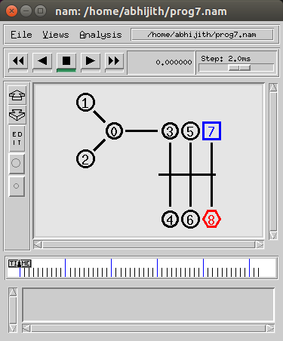

Step 4: Now press the play button in the simulation window and the simulation will begins.
Step 5: After simulation is completed run awk file and generate the graph , [root@localhost~]# awk –f prog5.awk cwnd.tr > a1 [root@localhost~]# awk –f prog5.awk cwnd2.tr > a2 [root@localhost~]#xgraph a1 a2

Step 6: To see the trace file contents open the file as ,

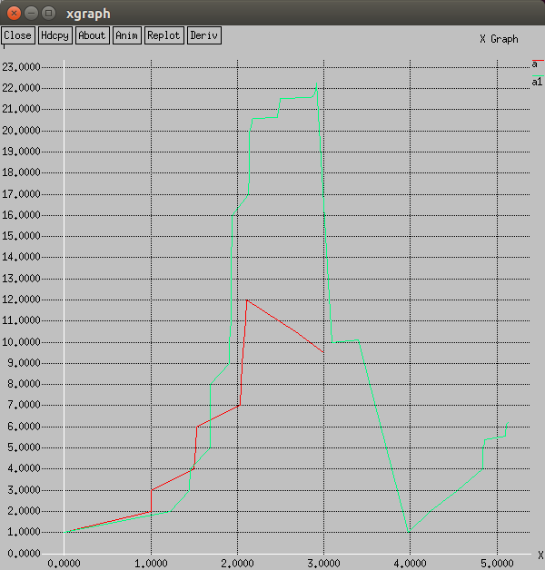
[root@localhost~]# vi prog5.tr

